Game Design Document

Fill up the Following document

1. Write the title of your project.

Jump and Reach

1. What is the goal of the game?

The goal of the game is that the player has to jump over obstacles and reach to their destination.

1. Write a brief story of your game?

The player in this game will be getting a lot of troubles to reach at the

end….It is going to be a very interesting game..Troubles in the game

Will the game even more interesting.

1. Which are the playing characters of this game?

* Playing characters are the ones which respond to the user based on the input from the user
* Cars, monkeys, dinos, wizards etc, are the playing characters in the game.

|  |  |  |
| --- | --- | --- |
| Number | Character Name | What can this character do? |
| 1 | Dog | It can move up,right and left. |
| 2 |  |  |
| 3 |  |  |
| 4 |  |  |
| 5 |  |  |
| 6 |  |  |
| 7 |  |  |
| 8 |  |  |

1. Which are the Non Playing Characters of this game?

* Non Playing characters are the ones which don't have an action or a behaviour when the user interacts with the game.
* Hurdles, stones, bananas, coins, etc are non playing characters in the game.

|  |  |  |
| --- | --- | --- |
| Number | Character Name | What can this character do? |
| 1 | Stones | - |
| 2 | Coins |  |
| 3 |  |  |
| 4 |  |  |
| 5 |  |  |
| 6 |  |  |
| 7 |  |  |
| 8 |  |  |

Draw your imagination of this game. What does this game look like?

* Draw the game either on your computer or on paper,
* Add images of scenes of the game to show each of the playing and non-playing characters at least once.

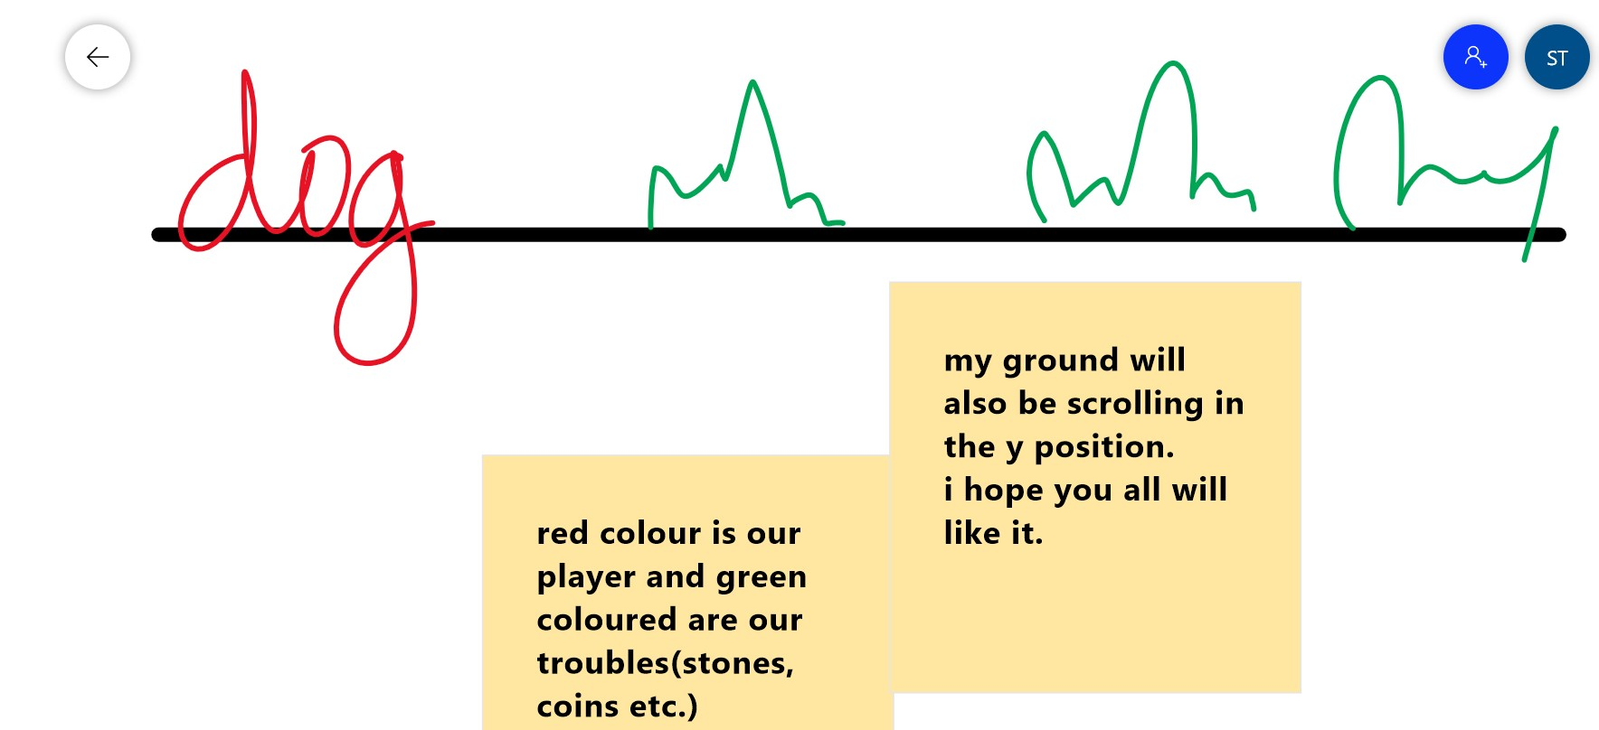

How do you plan to make your game engaging?

By adding more and more game designing elements.